2
PART TWO | Family
2A | 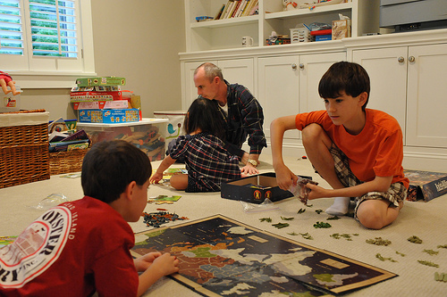
The following ideas may help you:

- Place
- People (appearance, clothes etc.)
- Activities
- Things/Equipment
- Atmosphere
- Other
2B | 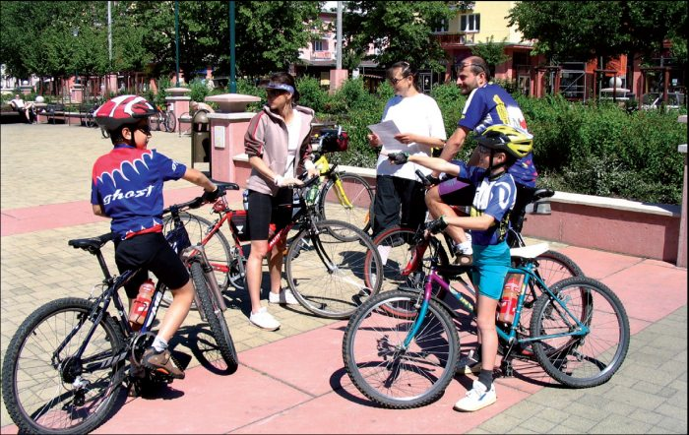

A

